Student Performance Prediction System

Project Id: AIML-5

Name: Member1 (Stuti)
Class Roll Number: 69
University Roll Number: 2028866
Section and Group: P (g-2)

Name: Shaurya Mittal
Class Roll Number: 64
University Roll Number: 2028847
Section and Group: P(g-2)

Name: Tilak Singh
Class Roll Number: 73
University Roll Number: 2028883
Section and Group: P(g-2)

TABLE OF CONTENTS
- Problem Description 3
  - Dataset Description 3
  - Flow diagram 4
- Modules for Project Implementation…………………..…………………………5
  - Modules Used 5
  - Platform Used 6
- Machine Learning model/ Searching Technique used 7
- Evaluation metrics used 8
- Results and Visualizations 9
- Conclusion and Future Scope 11
- References 12

- Problem Description
urban water demand prediction is an important task in smart city management and sustainable resource planning. Increasing population growth, changing climate conditions, and rising household consumption have created pressure on urban water supply systems. Predicting water demand helps authorities optimize water distribution, reduce wastage, and improve resource management.
This project uses Machine Learning techniques to predict urban household water demand based on demographic and environmental factors.

1.1 Dataset Description

The dataset contains household-related and environmental features that influence urban water consumption.
📂 Dataset Attributes
Feature NameDescriptionHousehold SizeNumber of members in the householdSeasonal IndexSeasonal variation affecting water usageGarden AreaArea of garden/lawn requiring irrigationNumber of BathroomsNumber of bathrooms in the houseChildren CountNumber of children in the householdElderly CountNumber of elderly membersAppliance CountNumber of water-consuming appliancesTemperatureEnvironmental temperatureWater DemandTarget variable representing water consumption

1.2 Flow Diagram
1.2 Flow Diagram
┌──────────────────────────────┐ │ INPUT DATASET │ └─────────────┬────────────────┘ │ ▼ ┌──────────────────────────────┐ │ DATA PREPROCESSING │ │ • Cleaning │ │ • Normalization │ │ • Feature Scaling │ └─────────────┬────────────────┘ │ ▼ ┌──────────────────────────────┐ │ FEATURE ENGINEERING │ │ • Feature Selection │ │ • Correlation Analysis │ └─────────────┬────────────────┘ │ ▼ ┌──────────────────────────────┐ │ MACHINE LEARNING MODELS │ │ • Linear Regression │ │ • Decision Tree │ │ • K-Means Clustering │ └─────────────┬────────────────┘ │ ▼ ┌──────────────────────────────┐ │ PREDICTION MODULE │ └─────────────┬────────────────┘ │ ▼ ┌──────────────────────────────┐ │ RESULTS & VISUALIZATION │ └──────────────────────────────┘

Fig.1 Sample flow diagram.

2. Modules for Project Implementation

2.1 Modules Used(mention all the inbuilt/ custom modules used and the purpose)

2.1 Modules Used
📌 Data Collection Module
Used for importing and managing dataset records.
📌 Data Preprocessing Module
Handles:

Missing value handling

Data cleaning

Feature scaling

Normalization

📌 Feature Engineering Module
Performs:

Correlation analysis

Feature selection

Data transformation

📌 Model Training Module
Implements:

Linear Regression

Decision Tree

K-Means Clustering

📌 Prediction Module
Generates urban water demand predictions.
📌 Visualization Module
Displays:

Heatmaps

Regression graphs

Clustering graphs

Classification rep

2.2 Platform Used: (mention all the platforms with the reason of using it)

ComponentTechnology UsedProgramming LanguagePythonIDEJupyter Notebook / VS CodeLibrariesPandas, NumPy, Matplotlib, Seaborn, Scikit-learnVisualization ToolsMatplotlib, SeabornOperating SystemWindows/Linux

3. Machine Learning Model/ Searching Technique Used(Describe each ML model/ searching technique used)
3. Machine Learning Model / Searching Technique Used
📌 Linear Regression
Linear Regression predicts continuous water demand values using a linear relationship between input features and output.
Equation
y=β0+β1x1+β2x2+β3x3+β4x4+β5x5+β6x6+β7x7+β8x8y = \beta_0 + \beta_1x_1 + \beta_2x_2 + \beta_3x_3 + \beta_4x_4 + \beta_5x_5 + \beta_6x_6 + \beta_7x_7 + \beta_8x_8y=β0​+β1​x1​+β2​x2​+β3​x3​+β4​x4​+β5​x5​+β6​x6​+β7​x7​+β8​x8​

📌 Decision Tree
Decision Tree predicts water demand using hierarchical decision rules.
Advantages

Handles nonlinear relationships

Easy interpretation

Good prediction accuracy

📌 K-Means Clustering
K-Means is an unsupervised learning algorithm used to group households with similar water consumption patterns.
Clustering Equation
J=∑i=1k∑xj∈Ci∣∣xj−μi∣∣2J = \sum_{i=1}^{k}\sum_{x_j \in C_i} ||x_j - \mu_i||^2J=∑i=1k​∑xj​∈Ci​​∣∣xj​−μi​∣∣2

4. Evaluation metrics used (Describe each evaluation metric used along with formulae)

5. Results and Visualizations

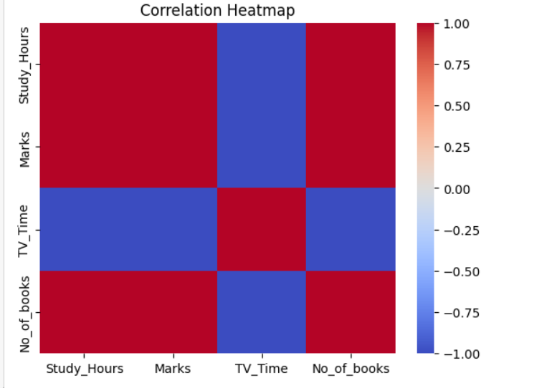

Fig.2 Heatmap showing corelation.

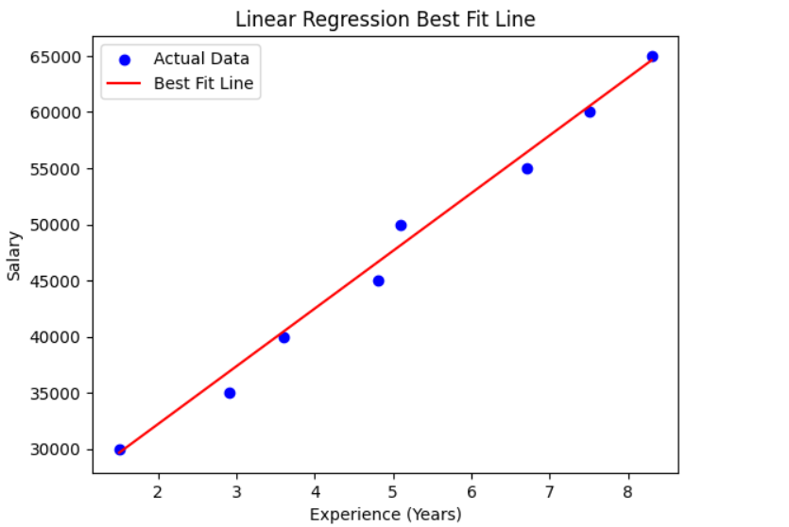
Fig.3

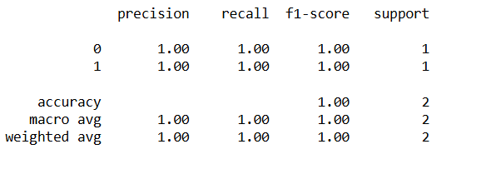
Fig.4

6. Conclusion and Future Scope:

7. References:
Books:
- Let Us Python – Yashavant Kanetkar

Online Resources:
  - GeeksforGeeks – https://www.geeksforgeeks.org/
  - TutorialsPoint – https://www.tutorialspoint.com/cprogramming/index.htm
  - Stack Overflow – https://stackoverflow.com

